**NATIONAL INSTITUTE OF TECHNOLOGY SILCHAR**

**Cachar, Assam**

**B.Tech. IVth Sem**

**Subject Code:** CS216

**Subject Name:** Applied Probability

**Submitted By:**

Name : Subhojit Ghimire

Sch. Id. : 1912160

Branch : CSE – B

1. **Write down steps required to perform Kolmogorov-Smirnov Test in R programming with the help of an example. Also take two samples x1 and x2 and visualise it by plotting a graph of the test result using R.**

* **Steps:**

1. **Install ‘dgof’ package and load it.**

> install.packages (“dgof”)

> library (dgof)

1. **Generate samples x and y using the functions rnorm() and runif().**

# rnorm () is used to generate random variates

> x <- rnorm (50)

# runif () is used to generate random deviates.

> y <- runif (30)

1. **Perform Kolmogorov-Smirnov Test on the samples x and y using the function ks.test().**

> ks.test (x, y)

**Example:**

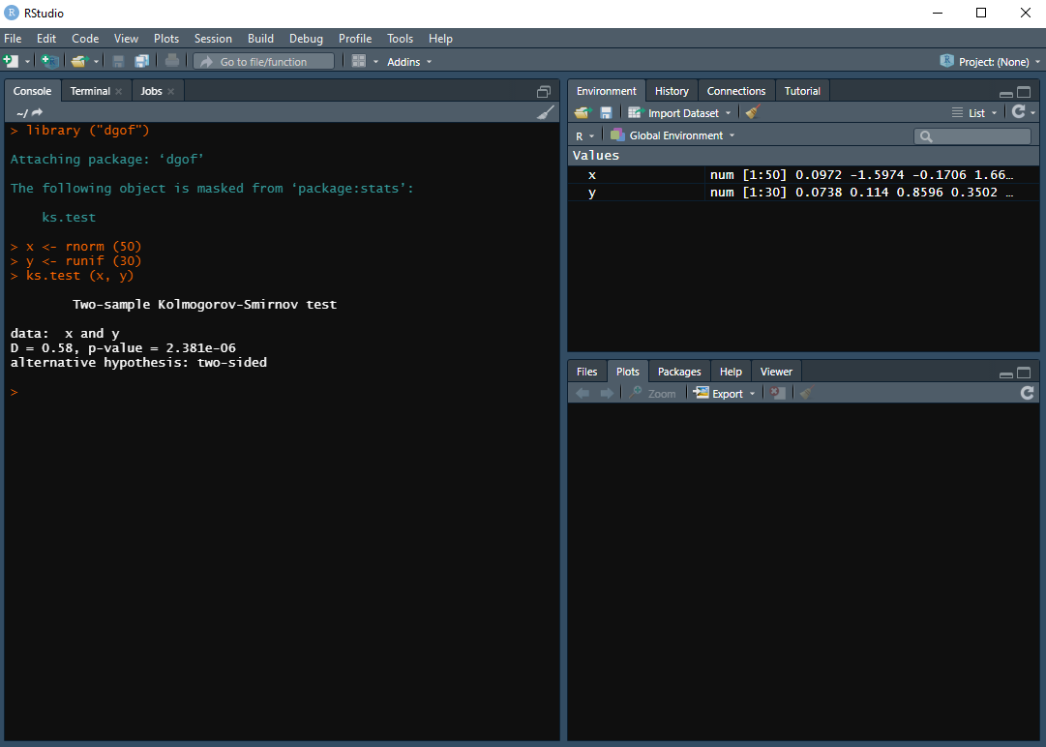

**Graph visualisation of two samples x1 and x2:**

